**September 2024 Issue**

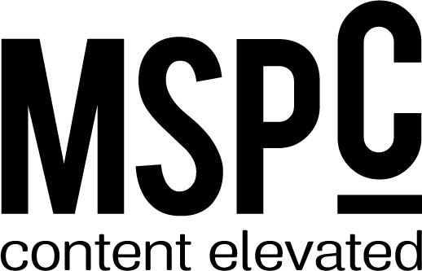



**Flourish/From the Top**

**People:** Rebecca Romero Rainey, Lucas White

**Banks:** The Fountain Trust Company in Covington, Ind.  
**Initiatives:** *Finding Balance: How Well-Intended Policies Hamper Small Business Lending and Undermine Relationship Banking,* ICBA Action Center

**Currencies**

**People:** N/A

**Banks:** United Bank in Atmore, AL

Lake Ridge Bank in Monona, WI

**Initiatives:** N/A

**Social Network Banks:**

Bank of Clarendon in Manning, SC

Williamstown Bank in Williamstown, WV

**Portfolio**

**Supporting ag lending, rain or shine**

**People:** Mark Scanlan

**Banks:** The First State Bank in Boise City, OK

BTC Bank in Bethany, MO

**Initiatives:** N/A

**How to nurture relationships with next-gen customers**

**People:** N/A

**Banks:** Live Oak Private Wealth in Wilmington, NC

Live Oak Bank in Wilmington, NC

Bank of Charles Town in Charles Town, WV

Community Spirit Bank in Red Bay, AL

**Initiatives:** N/A

**How fintech relationships can lessen compliance burdens**

**People:** Charles E. Potts

**Banks:** N/A

**Initiatives:** ICBA ThinkTECH, ICBA Innovation, ICBA Solution Directory

**Are you ahead of the pack on instant payments?**

**People:** Scott Anchin

**Banks:** Buffalo Federal Reserve in Buffalo, NY

1st Bank Yuma in Yuma, AZ

**Initiatives:** N/A

**5 ways to make a good digital impression**

**People:** Emma Darnell

**Banks:** Plumas Bank in Quincy, CA

Woodsboro Bank in Woodsboro, MD

Better Banks in Peoria, IL

**Initiatives:** N/A

**Will AI supercharge regtech?**

**People:** Charles Potts

**Banks:** N/A

**Initiatives:** N/A

**The 5 Ws of goal setting**

**People:** Lindsay LaNore

**Banks:** N/A

**Initiatives:** N/A

**Too much of a good thing?**

**People:** Michael Benedict (from Stifel)

**Banks:** N/A

**Initiatives:** ICBA Securities, ICBA Balance Sheet Academy

**The Supreme Court of the United States is reshaping administrative law**

**People:** Jenna Burke

**Banks:** N/A

**Initiatives:** N/A

**Features**

**From the heart (ICBA’s 2024 NCBSAs)**

**Better futures for kids, one lemonade stand at a time**

**People:** N/A

**Banks:** Phelps County Bank in Rolla, MO

**Initiatives:** N/A

**Planting trees for the good of Chesapeake Bay**

**People:** N/A

**Banks:** Woodsboro Bank in Woodsboro, MD

**Initiatives:** N/A

**Opening up funding in local nonprofits**

**People:** N/A

**Banks:** Ulster Savings Bank in Kingston, NY

**Initiatives:** N/A

**Beyond apples: Getting teachers what they need**

**People:** N/A

**Banks:** FreedomBank in Elkader, IA

**Initiatives:** N/A

**Three major compliance challenges – and solutions**

**People:** Mandy Snyder

**Banks:** Grand Rapids State Bank in Grand Rapids, MN

**Initiatives:** ICBA study from June 2024, ICBA certified programs and targeted trainings, ICBA Education, ICBA Community, ICBA ThinkTECH Accelerator, ICBA Current Issues Certification Conference, ICBA Compliance Institute, ICBA Bank Secrecy Act/Anti-Money Laundering Institute, ICBA online Bank Compliance Center

**Bigger banks, local feel**

**People:** Ron Haynie

**Banks:** First Federal Bank of Louisiana in Lake Charles, LA

D.L. Evans Bank in Burley, ID

Lake Ridge Bank in Monona, WI

Unity Bank in Clinton, NJ

**Initiatives:** ICBA Large Community Bank Council

**Connections**

**Turning business banking into a conversation**

**People:** N/A

**Banks:** Endeavor Bank in San Diego, CA

**Initiatives:** N/A

**Joining forces to support affordable housing initiatives**

**People:** N/A

**Banks:** Umpqua Bank in Lake Oswego, OR

Federal Home Loan Bank of Des Moines in Des Moines, IA

**Initiatives:** N/A

**Strengthening community banking state by state**

**People:** Joe Schneider, Aaron Stetter

**Banks:** N/A

**Initiatives:** ICBA Foundation, ICBA state association directory

**How to use AI at your community bank**

**People:** Charles Potts

**Banks:** BAC Community Bank in Stockton, CA

**Initiatives:** *Independent Banker: A Community Banking Podcast from ICBA*

**Out of Office**

**Banks:** Waterford Bank N.A. in Toledo, OH